1.69:
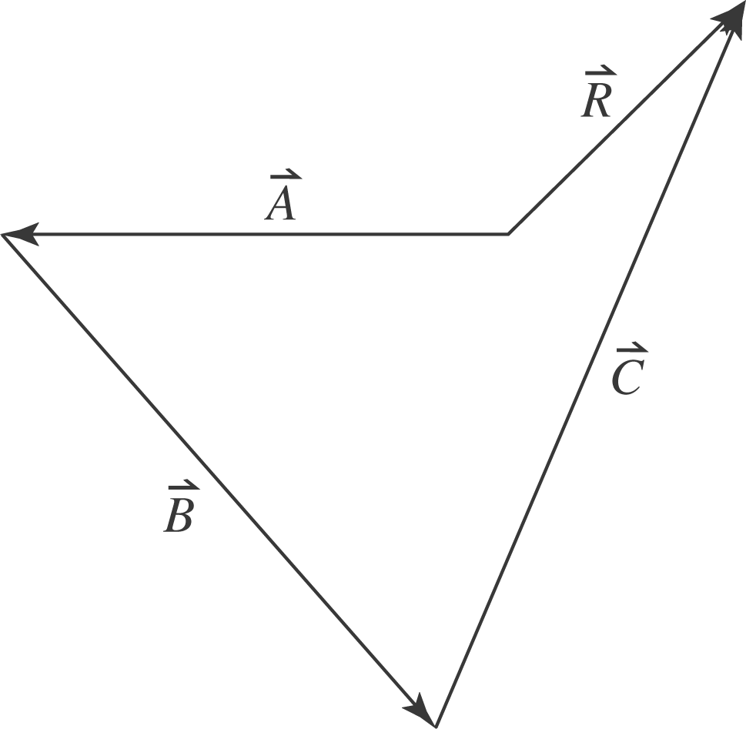

Take the east direction to be the direction and the north direction to be the 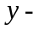direction. The x- and y-components of the resultant displacement of the
first three displacements are then

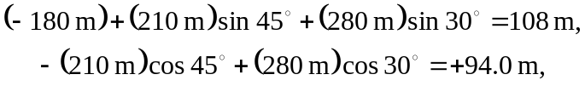

keeping an extra significant figure. The magnitude and direction of this net displacement are
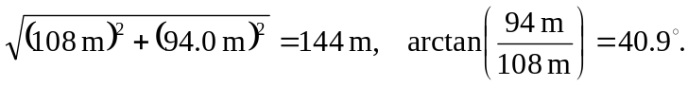
The fourth displacement must then be 144 m in a direction 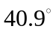south of west.

